Database Schema

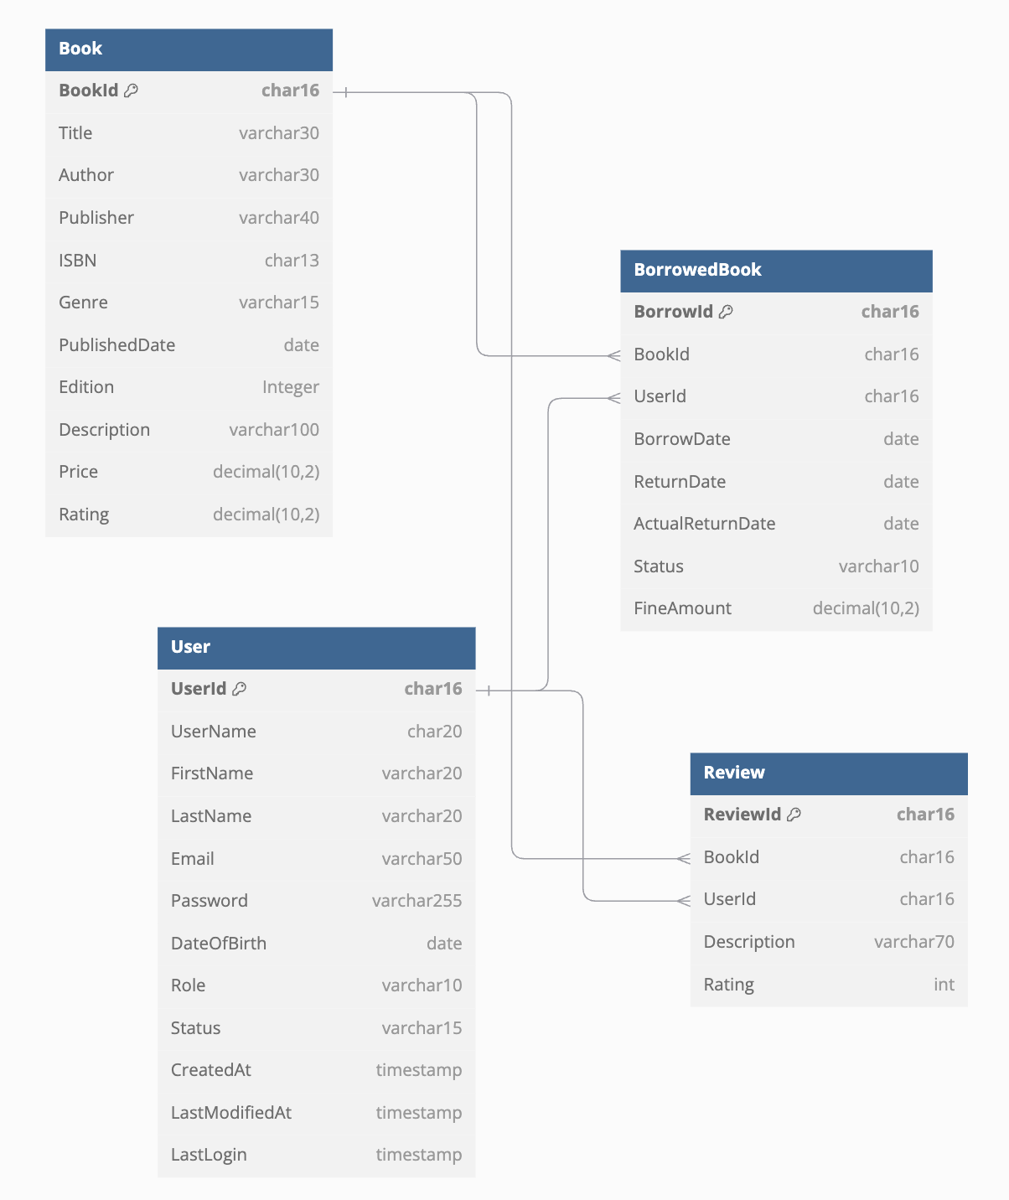

Created using dbdiagram.io, Below is the schema definition

Table Book {

BookId char16 [primary key]

Title varchar30

Author varchar30

Publisher varchar40

ISBN char13

Genre varchar15

PublishedDate date

Edition Integer

Description varchar100

Price decimal(10,2)

Rating decimal(10,2)

}

Table User {

UserId char16 [primary key]

UserName char20 [unique]

FirstName varchar20

LastName varchar20

Email varchar50

Password varchar255

DateOfBirth date

Role varchar10

Status varchar15

CreatedAt timestamp

LastModifiedAt timestamp

LastLogin timestamp

}

Table BorrowedBook {

BorrowId char16 [primary key]

BookId char16

UserId char16

BorrowDate date

ReturnDate date

ActualReturnDate date

Status varchar10

FineAmount decimal(10,2)

}

Ref: User.UserId < BorrowedBook.UserId

Ref: Book.BookId < BorrowedBook.BookId

Table Review{

ReviewId char16 [primary key]

BookId char16

UserId char16

Description varchar70

Rating int

}

Ref: User.UserId < Review.UserId

Ref: Book.BookId < Review.BookId